Ontology-based Expert System for a Generic Drug Production of Pharmaceutical Dosage Forms

Project Plan

By

**Mr. Narongrit Saisuwan 542115017**

**Mr. Panupak Wichaidit 542115047**

Department of Software Engineering

College of Arts, Media and Technology

Chiang Mai University

Project Advisor

………………………………………..

**Dr. Chartchai Doungsa-ard**

# Document History

|  |  |  |  |  |  |  |
| --- | --- | --- | --- | --- | --- | --- |
| **Document Name** | **Version** | **Status** | **Date** | **Viewable** | **Reviewer** | **Responsible** |
| **Documents** | | | | | | |
| **Ontology-based Expert System for a Generic Drug Production of Pharmaceutical Dosage Forms –Project Plan v.1.0.docx** | **1.0**   * Introduction * System Architecture * Deliverables and Limit * Schedule & Milestones | Release | February 28, 2014 | NS, PW, CD | NS, PW | NS, PW |
| **Ontology-based Expert System for a Generic Drug Production of Pharmaceutical Dosage Forms –Project Plan v.1.0.docx** | **1.1**   * Deliverables and Limit * Schedule & Milestones * Infrastructure * Management Procedures * Version Control Strategy | Release | June 30, 2014 | NS, PW, CD | NS, PW | NS, PW |

Table of Contents

Document History ii

Chapter 1 | Introduction 1

1.1-Motivation 1

1.2-Aim 1

1.3-Objective 1

Chapter 2 | System Architecture 2

Chapter 3 | Deliverables and Limits 3

3.1 Deliverables 3

3.2 Limit 5

Chapter 4 | Infrastructure 6

4.1 Software Development Life Cycle 6

4.2 Software Acquisition Plans 7

4.2.1 Design Tools 7

4.2.2 Development Tools 7

4.2.3 Configuration Management Tools 7

4.2.4 Document Tools 7

4.2.5 Testing Tools 7

4.3 Hardware and Material Resources 7

Chapter 5 | Management Procedures 8

5.1 Project Team Structure 8

Chapter 6 | Schedule & Milestones 9

6.1 Schedule Plan 9

Chapter 7 | Version Control Strategy 14

7.1 Naming Conversion 14

7.2 Project Repository 14

7.3 Configuration Item Table 16

# Chapter 1 | Introduction

## 1.1-Motivation

The price of original drugs, which is under patent protection, is always expensive because of research and development costs. So this reasons make poor people, in developing countries, cannot pay for curing their sickness or disease. For solve this problem, the local pharmaceutical corporations try to develop a new drug manufacturing that call reformulating drugs into a generic version after the patent protection expired.

The pharmaceutical formulation process is a highly specialize task requiring specific domain knowledge and often years of experience. Expert system derived from research into artificial intelligence support the efficient formulation of products and therefore increase productivity, consistency and quality.

Follow the issue above, Ontology-based Expert System for a Generic Drug Production of Pharmaceutical Dosage Forms can help an inexperienced industry pharmacists to reproduce a generic drug in the right way and the right time.

## 1.2-Aim

The aim of this project is to develop mobile application on Tablet computer. Ontology-based Expert System for a Generic Drug Production of Pharmaceutical Dosage Forms recommend a solution for reformulating an original drug into a generic version. The generic production receives a pharmaceutical value and shows result as a drug formula, manufacturing and excipients. The experience pharmacist can use Ontology-based Expert System for a Generic Drug Production of Pharmaceutical Dosage Forms for reformulating drug.

## 1.3-Objective

* To recommend a generic production that consist of a formula and its instructions.
* To evaluate the generic drug production comparing with the original drug.
* To suggestion the generic production, which is not equivalent to the original drug, until it equivalent to its original.

# Chapter 2 | System Architecture

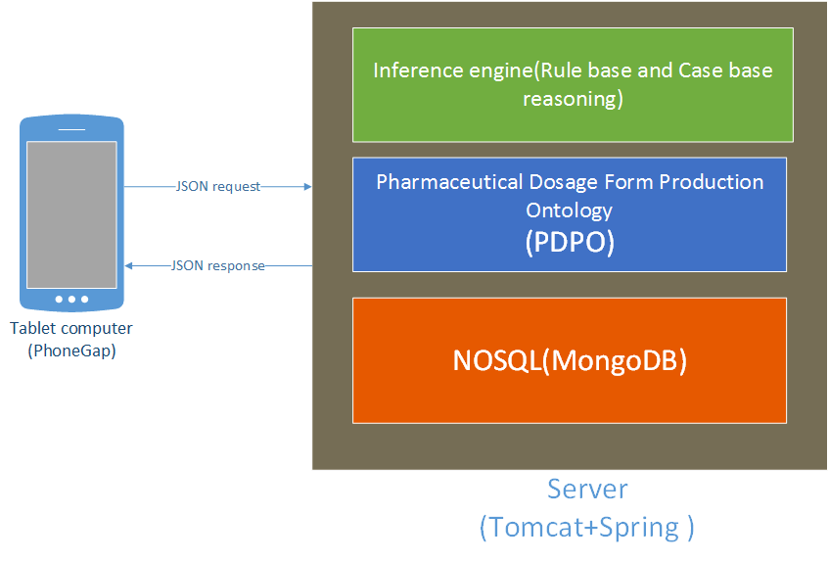

**Figure 1: System Architecture.**

Figure 9 show the system architecture of Ontology-based Expert System for a Generic Drug Production of Pharmaceutical Dosage Forms. Firstly, the system receives an input data from a user via tablet computer. Then it send the data to the server in JSON format. After that, the system on server will recommend an appropriate solutions using rule base technique and/or case base reasoning. Finally the system returns a drugs reformulation with manufacturing and excipients to the user.

# Chapter 3 | Deliverables and Limits

### 3.1 Deliverables

##### 3.1.1 Architecture Overview

From the system architecture on Figure 8, Ontology-based Expert System for a Generic Drug Production of Pharmaceutical Dosage Forms can be divided into many subsystem such as the user management system, the rule base system, the case base reasoning system, hybrid reasoning system and the pharmaceutical tablet production on ontology. The server side is develop on JAVA programming and with apache server. The structure of architecture overview is illustrated in Figure 10

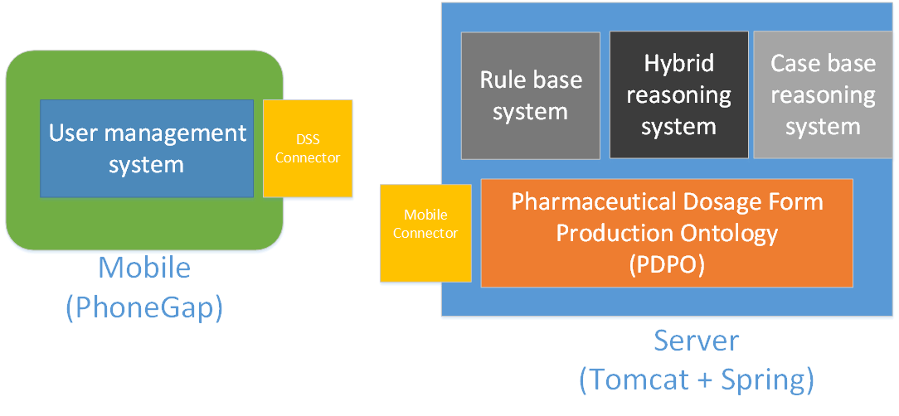

**Figure 2: System Architecture overview**

The subsystem can group into two main parts. The first one is a mobile part, and the second is a server part.

###### Mobile Part

* **Feature 1 : User management system**

There are two types of users in Ontology-based Expert System for a Generic Drug Production of Pharmaceutical Dosage Forms. The first one is experience pharmacists. This user uses the system for evaluating generic drugs production comparing with the original drug production. The experience pharmacists also use the system for suggested an appropriate manufacturing and excipients to reformulate a drug and they can create and/or add a new case by themselves. The second is inexperience pharmacists. This user uses the system similar with experience pharmacists, but they cannot add add/or create any of a new pharmaceutical case.

###### Server part

* **Feature 2 : Rule base system**

Rule base system is one part of inference engine that using for suggesting the reformulate an original drug as a generic version. Rule base system can decide a drug reformulating by “rule “. The rule is come from a set of pharmaceutical knowledge that call PDPO (Pharmaceutical dosage form production ontology). The rule base system receive a pharmaceutical value and show an appropriate result as a manufacturing and excipient to the user.

* **Feature 3 : Case base reasoning system**

Case base reasoning system is one part of inference engine like a Rule base system. Ontology-based Expert System for a Generic Drug Production of Pharmaceutical Dosage Forms uses a case base reasoning system for reformulating an original drug and comparing the generic drug production with original drug production. The experience pharmacists can use the case base reasoning system for creating and adding a new case into the system. The new case base used to reformulate an original drug like existing case base.

* **Feature 4: Hybrid reasoning system**

Hybrid reasoning system is an inference engine that combine with Case base reasoning and Rule base system. The system is suggest to reformulate an original drug into a generic version. The pharmacists can use the hybrid reasoning system for creating and adding a new case into the system like Case base reasoning system.

* **Feature 5 : Pharmaceutical Dosage Form Production Ontology(PDPO)**

Pharmaceutical dosage form production ontology is kept as set of knowledge. The rule base and the case base reasoning use PDPD for calculating an appropriate reformulate drugs the reformulate an original drug as generic version.

* **Feature 6 : DSS connector**

DSS connector is a system at mobile part which sending and receiving a data between users and a server. DSS connector receive a data from a user interface and send data to PDPO for find a drug reformulation Additionally, DSS connector can receive a result from PDPO and show it to a user.

* **Feature 7 : Mobile connector**

Mobile connector is a system at server part which sending and receiving a data between users and a server. Mobile connector receive an input data from mobile part and send data to PDPO for suggesting a reformulate original drugs as generic drug production; furthermore Mobile connector sends a result to mobile part.

##### 3.1.2 Documents

|  |  |  |  |  |
| --- | --- | --- | --- | --- |
| **No.** | **Deliverables/Release** | **Media** | **No. of Copies** | **Date** |
| 1 | **Project Proposal**  • Ontology-based Expert System for a Generic Drug Production of Pharmaceutical Dosage Forms Version 1.1 | Document | 3 | 5th March 2014 |
| 2 | **Progress Report I**  • Project Plan Version 1.0  • Software Requirement Specification  Version 1.0  • Software Design Document Version 1.0  • Test Plan Version 1.0  • Traceability Record Version 1.0  • Software Version 1.0 | Document | 3 | 7th July 2014 |

### 3.2 Limit

* The user require a Tablet computer and internet connection.
* Ontology-based Expert System for a Generic Drug Production of Pharmaceutical Dosage Forms is appropriated with a person who has a pharmacy knowledge.

# Chapter 4 | Infrastructure

## 4.1 Software Development Life Cycle

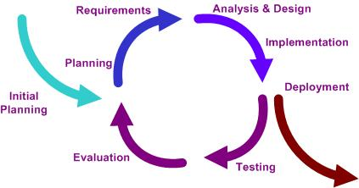

**Figure 3 Iterative Development Model**

Figure 1 presents a method of software development. Iterative development model is a cyclic software development process developed in response to the weaknesses of the Waterfall model. The model starts with planning and continues through iterative development cycles.

Ontology-based Expert System for a Generic Drug Production of Pharmaceutical Dosage Forms. Developer can use model to develop the iterative way to fulfill, change software and document for each development process.

## 4.2 Software Acquisition Plans

### 4.2.1 Design Tools

* Photoshop CS6
* Adobe Dreamweaver CS6

### 4.2.2 Development Tools

* Eclipse Kepler
* IntelliJ 12.1.6

### Configuration Management Tools

* GitHub

### 4.2.4 Document Tools

* Microsoft Word 2013

### 4.2.5 Testing Tools

* IPad 2
* Notebook with Google chrome or Firefox browser
* Host Server

## 4.3 Hardware and Material Resources

* **Internet**
* **Computers**
  + Apple Macbook Pro mid 2013
    - Processor: Intel® Core™ i7-3520M CPU @ 2.90GHz 2.90GHz
    - RAM: 8.00 GB
    - Operating System: Windows 7 Ultimate, OSX maverick
  + Dell Inspiron n5110
* Processor: Intel® Core™ i5-2410M CPU @ 2.30GHz 2.30GHz
* RAM: 4.00 GB
* Operating System: Windows 8.1 Professional
* **Tablet Computer**
  + Ipad 2

# Chapter 5 | Management Procedures

## 5.1 Project Team Structure

|  |  |  |
| --- | --- | --- |
| **Participants** | **Roles** | **Responsibility** |
| Panupak Wichaidit  and  Narongrit Saisuwan | • Developer  • Tester  • Reviewer | •         Create document  - Proposal  - Project Plan  - Software requirement specification  - Software Design Document  - Test Plan  - Test Record  - Traceability Record  •         Develop software  •         Test software  •         Review document and software  •         Mange change |

# Chapter 6 | Schedule & Milestones

The schedule and milestones of Ontology-based Expert System for a Generic Drug Production of Pharmaceutical Dosage Forms. During period of time, there are work terminologies. And the description is shown below that:

* **Feature 1 : User management system**
* **Feature 2 : Rule base system**
* **Feature 3 : Case base reasoning system**
* **Feature 4 : Hybrid reasoning system**
* **Feature 5 : Pharmaceutical Dosage Form Production Ontology(PDPO)**
* **Feature 6 : DSS connection system**
* **Feature 7 : Mobile connector**

## 6.1 Schedule Plan

|  |  |  |  |
| --- | --- | --- | --- |
| Milestone | Task | Milestone Criteria | Planned date |
| 1 | Proposal | * Topic defined | February |
| 2 | Proposal | * Proposal reviewed * Proposal submitted * Proposal presentation | 5th March 2014 |
| 3 | Progress Report I | * Software requirement specification * Feature 5 * Software design document * Test Plan * Feature implemented * Feature test report * Traceability record progress I * Progress report I submitted * Progress report I presentation   STMS-Proposal Milestone.jpg | 7th July 2014 |
| 4 | Progress Report II | * Feature 2, Feature 3 , Feature 6 , and Feature 7 * Software design document * Test Planed * Feature implementation * Feature test report * Traceability record progress II * Progress report II submitted * Progress report II presentation | 3rd September 2014 |
| 5 | Progress Report III | * Feature 4,Feature 1 * Software design document * Test Planed * Feature implementation * Feature test report * Traceability record progress III * Progress report III submitted * Progress report III presentation | December |

D:\All for desktop\Senior project\Project Plan\progress report 1 milestone.tif

D:\All for desktop\Senior project\Project Plan\progress report 2 milestone.tif

D:\All for desktop\Senior project\Project Plan\progress report 3 milestone.tif

# Chapter 7 | Version Control Strategy

## 7.1 Naming Conversion

For naming conversion of Emergency Information on Mobile project, the name of document and software will be named as following format:

“[Project Name]-[Document Name]-[Version].[File Type]”

* **Project Name**

This part will be the name of this project that is “Ontology-based Expert System for a Generic Drug Production of Pharmaceutical Dosage Forms”

* **Document Name**

This part will depend on substance of that file. In each file will has its certain name as following:

* Proposal
* Project Plan & Quality Plan
* Software Requirement Specification (SRS)
* Software Design Document (SDD)
* Implementation
* Test Plan
* Test Record
* Traceability Record (TR)
* **Version**

This part is the version of document. Version number will be in the following format:

“V.[Main version].[Sub version]”

* **File Type**

This part is the type of file or the file extension. For example, .docx, .pdf.

## 7.2 Project Repository

* **GitHub**

GitHub is a tool that can help to manage the version of document and software. Developers can share file or update version of file anytime that they want. Developers have to have their own account of GitHub. Then the developers can create project file and can share it with anyone they want.

For Ontology-based Expert System for a Generic Drug Production of Pharmaceutical Dosage Forms, we will create folders to be the project repository as following:

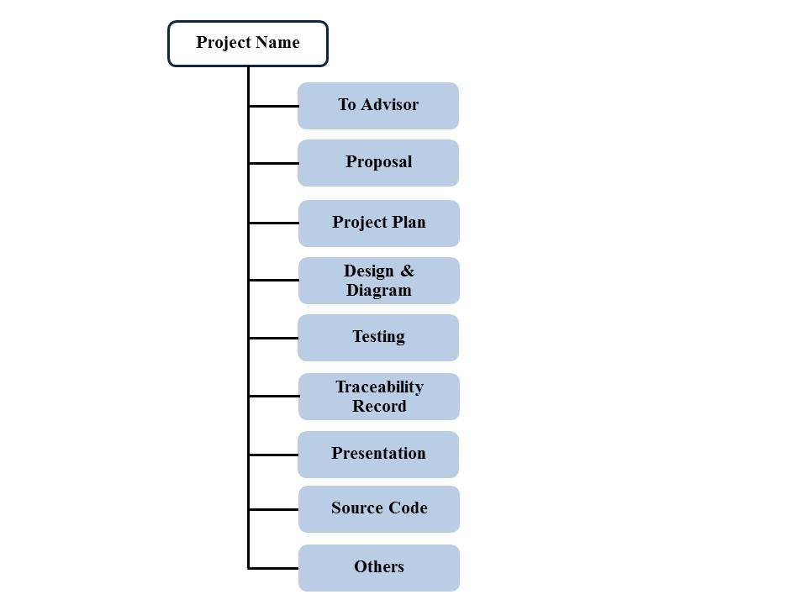

**Figure 3: Repository of Ontology-based Expert System for a Generic Drug Production of Pharmaceutical Dosage Forms**

**List of related document and description**

* To Advisor: contain document files that will be waiting to be reviewed by advisor.
* Proposal: contain involving proposal files.
* Project plan: contain project plan document files.
* Design & Diagram: contain design and diagram document files.
* Testing: contain testing document files.
* Traceability record: contain traceability record document
* Presentation: contain presentation files.
* Source code: contain source code of project.
* Others: contain kind of picture, server information, interesting web site and etc.

## 7.3 Configuration Item Table

|  |  |  |  |  |  |  |
| --- | --- | --- | --- | --- | --- | --- |
| **No.** | **Item** | **File Name** | **File Type** | **Owner** | **Path** | **Baseline** |
| 1 | Project Proposal | Ontology-based Expert System for a Generic Drug Production of Pharmaceutical Dosage Forms -ProjectProposal-V.1.0 | .docx | Panupak, Narongrit | Proposal | 1.0 |
| 2 | Development and Quality Plan | Ontology-based Expert System for a Generic Drug Production of Pharmaceutical Dosage Forms -Project Plan -V.1.0 | .docx | Panupak, Narongrit | Project Plan | 1.0 |
| 3 | Software Requirement Specification | Ontology-based Expert System for a Generic Drug Production of Pharmaceutical Dosage Forms –Software requirement specification -V.1.0 | .docx | Panupak, Narongrit | Design&Diagram | 1.0 |
| 4 | Software Design Document | Ontology-based Expert System for a Generic Drug Production of Pharmaceutical Dosage Forms –Software design document-V.1.0 | .docx | Panupak, Narongrit | Design&Diagram | 1.0 |
| 5 | Test Plan | Ontology-based Expert System for a Generic Drug Production of Pharmaceutical Dosage Forms -Test Plan-V.1.0 | .docx | Panupak, Narongrit | Testing | 1.0 |
| 6 | Test Record | Ontology-based Expert System for a Generic Drug Production of Pharmaceutical Dosage Forms -Test Record-V.1.0 | .docx | Panupak, Narongrit | Test Record | 1.0 |
| 7 | Traceability Record | Ontology-based Expert System for a Generic Drug Production of Pharmaceutical Dosage Forms -Traceability Record-V.1.0 | .docx | Panupak, Narongrit | Traceability Record | 1.0 |